# Subject: 20CS2036L – Web Technology Lab Reg No:URK22AI1048

**Lab Exercise: 2. Working with HTML5 Form and Media Elements (Duration:**

# 1.30 hours)

**Design a website that conforms to HTML5 standards and has the following elements:** doctype, html, title, body, head, div, p, headings, image, anchor, table, audio, video, embed, iframe, form, input, select, progress, fieldset, label, html comment etc..

## Write the description of the tags and its syntax by referring w3schools.com.

Your site consists of two pages. First page is a company home page. Second page has a form for the job seekers to submit their resume.

## Guidelines for designing the First Page: (home.html)

1. First page has three sections such as header, navigation, content section and footer **(Use table for Layout with border=0)**
2. **Header section:** Header should be at the top of the page. It contains the company name and logo image. Align the text at center using the style “text-align: center”. Align the image at right side using the style “align: right”.
3. **Navigation section:** include the navigation links such as Media Elements (home.html) and Application Form (application.html)
4. **Content section** has four sections.
5. Section 1: Have a banner image fully cover the page width.
6. Section 2: Have two columns
   * In first column display required skill set using progress bar with suitable value and necessary HTML tags.
   * Include the audio in the Second column. The audio will automatically start playing as soon as the page loads without stopping.
7. Section 3: Have two columns **(Embed tag)**
   * Embed PDF document in the first column.
   * Embed the YouTube video in the second column.
8. Section 4: Have two columns
   * Include a video using video tag in the first column. Play the video when the user clicks on the play button.
   * Embed the Google Map in the second column using iframe.
9. **Footer section:** copyright information.

## Guidelines for designing the Second Page: (application.html)

1. Second page contains a form to collect the applicant details
2. Have the header and navigation section as in home.html
3. Form design
   * Design a form with an action value of submit.php and method value of ”get”. Code the form with auto complete active. This form contains both required and optional fields. Asterisk (*) before each field indicates required fields and other fields are optional.
   * Place the form contents inside the fieldset tag and validate the form fields according to the validation rules.
   * Required field should not be empty.
   * Name field you create should have autofocus, placeholder text, and be required.
   * The application number field should have placeholder text, a pattern to restrict entry, and be required. The format is KU20201CS1XXX
   * Password field should have at least 8 characters.
   * The age field should have a minimum value of 18 and a maximum value of 35.
   * The mobile number field should have placeholder text, a pattern to restrict entry. Phone Number is either only 10 numbers or in the format (+91) 99999-99999.
   * The email address field should have placeholder text. This field should also be required. Mail address in the format [xxxxxxxx@karunya.edu.in](mailto:xxxxxxxx@karunya.edu.in).
   * Zip Code is only 6 numbers in the format 999999.
   * The course list should have a dropdown list.
   * Limit the user to choose only jpg and png file. Prevent them from choosing files of any type or extension.
   * Use calendar, checkbox, radio button, textarea, in the necessary places.
   * Finally add a submit button at the end.
4. Appropriate use of HTML comments.
5. Set a background color and text color, align the content in the web page [use style attribute].
6. All HTML pages must pass the official HTML5 specifications via <https://validator.w3.org/>
7. Publish your website live on web using any free web hosting services (000webhost).
8. Use the mockup illustration page given below.

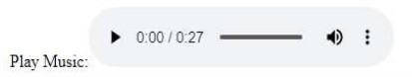Here is the mockup illustration of the site. Your result should look very close to this mockup.

**Company name **

**Media elements Application Form**

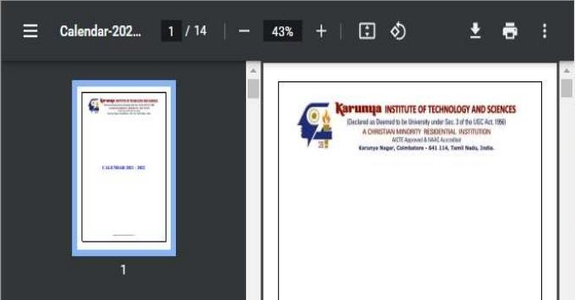

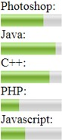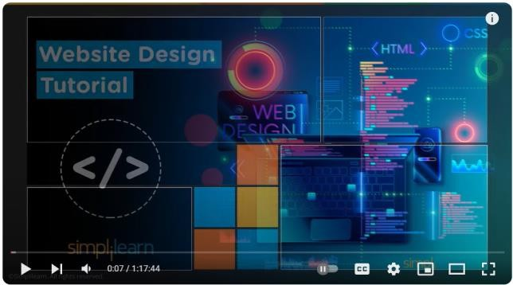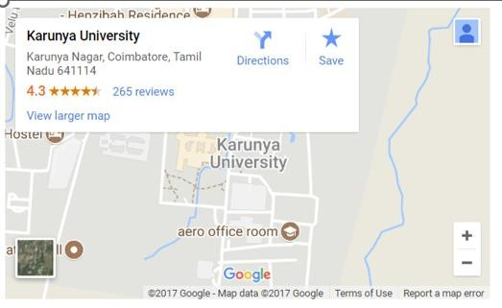

Company address

@ 2023-2024 (URK22AI1XXX) – Web Technology Lab. All rights reserved.

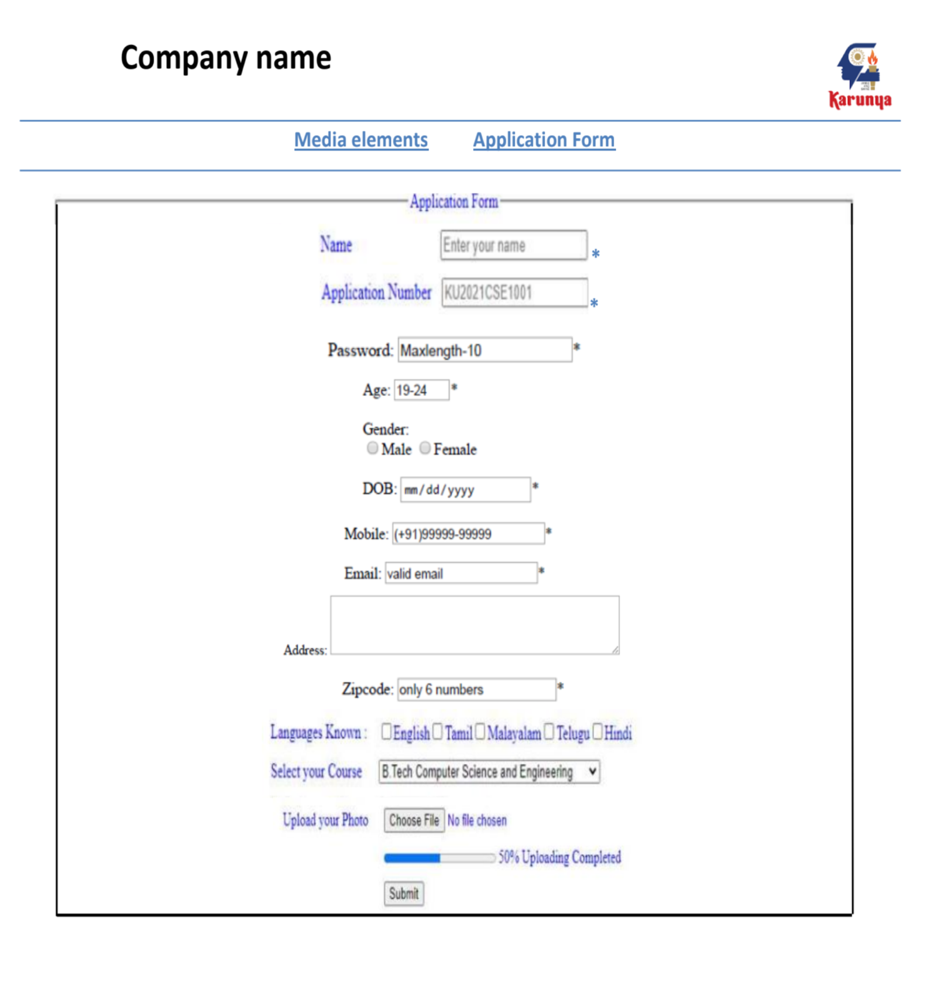

**Source Code:**

INDEX HTML CODE:

<!DOCTYPE html>

<html lang="en">

<head>

<meta charset="UTF-8">

<meta name="viewport" content="width=device-width, initial-scale=1.0">

<title>KARUNYA PAGE</title>

<link rel="icon" type="image/x-icon" href="fav.jpg">

</head>

<body>

<div>

<table width="100%">

<tr>

<td width="70%" align="left">

<h2 >KARUNYA INSTITUTE OF TECHNOLOGY AND SCIENCES - DEEMED UNIVERSITY</h2>

</td>

<td width="50" align="right">

<img src="klogo.png" alt="Logo pic" width="100" height="100">

</td>

</tr>

</table>

</div>

<hr color="blue">

<div align="center">

<a href="index.html">Media Elements</a>&nbsp; &nbsp;

<a href="application.html" target="_blank">Application Form</a>

</div>

<hr color="blue">

<div align="center">

<img src="img1.jpeg" width="1500" height="100" alt="drone image of karunya UNIVERSITY">

</div>

<hr color="blue">

<div>

<table border="0" width="100%">

<tr>

<td width="50%" align="left">

<label for="photoshop">Photoshop:</label><br>

<meter id="photoshop" value="0.75"></meter><br>

<label for="java">Java:</label><br>

<meter id="java" value="0.9"></meter><br>

<label for="c++">C++:</label><br>

<meter id="c++" value="0.85"></meter><br>

<label for="php">PHP:</label><br>

<meter id="php" value="0.25"></meter><br>

<label for="Javascript">Javascript:</label><br>

<meter id="Javascript" value="0.45"></meter><br>

</td>

<td width="40" align="center">

<p>Play Music:</p>

<audio controls autoplay="autoplay">

<source src="music.ogg" type="audio/ogg">

<source src="music.mp3" type="audio/mpeg">

</audio>

</td>

</tr>

<tr>

<td colspan="2"><hr color="blue"></td>

</tr>

<tr>

<td width="50%">

<embed src="calendar.pdf" type="application/pdf" height="325" style="width:90%;">

</td>

<td width="40%">

<iframe style="width: 90%" height="315" src="https://www.youtube.com/embed/vN2RGFflUf8?si=IRmg7Hn6EAxADSrG" title="YouTube video player" frameborder="0" allow="accelerometer; autoplay; clipboard-write; encrypted-media; gyroscope; picture-in-picture; web-share" allowfullscreen></iframe>

</td>

</tr>

<tr>

<td colspan="2"><hr color="blue"></td>

</tr>

<tr>

<td>

<iframe style="width: 90%;" height="315" src="https://www.youtube.com/embed/i9t8gdaBsTg?si=tzddm1dfMlntoF5-" title="YouTube video player" frameborder="0" allow="accelerometer; autoplay; clipboard-write; encrypted-media; gyroscope; picture-in-picture; web-share" allowfullscreen></iframe>

</td>

<td>

<iframe src="https://www.google.com/maps/embed?pb=!1m18!1m12!1m3!1d3917.3598134298013!2d76.74148607586996!3d10.936169256225229!2m3!1f0!2f0!3f0!3m2!1i1024!2i768!4f13.1!3m3!1m2!1s0x3ba866bd6aaaaaab%3A0xc650b8a75e7b51f0!2sKarunya%20Institute%20of%20Technology%20and%20Sciences%20(Deemed%20University)!5e0!3m2!1sen!2sin!4v1702632813298!5m2!1sen!2sin" style ="width:100%" height="350" allowfullscreen="" loading="lazy" referrerpolicy="no-referrer-when-downgrade"></iframe>

</td>

</tr>

<tr>

<td colspan="2"><hr color="blue"></td>

</tr>

<tr>

<td colspan="2">KARUNYA UNIVERSITY,KARUNYA NAGAR,COIMBATORE,TAMIL NADU-641114<br>@2023-2024 (URK22AI1048) - Web Technology Lab. All rights reserved.</td>

</tr>

<tr>

<td colspan="2"><hr color="blue"></td>

</tr>

</table>

</div>

</body>

</html>

APPLICATION HTML CODE:

<!DOCTYPE html>

<html lang="en">

<head>

<meta charset="UTF-8">

<meta name="viewport" content="width=device-width, initial-scale=1.0">

<title>APPLICATION PAGE</title>

<link rel="icon" type="image/x-icon" href="fav.jpg">

</head>

<body>

<div>

<table width="100%">

<tr>

<td width="70%">

<h2>KARUNYA INSTITUTE OF TECHNOLOGY AND SCIENCES - DEEMED UNIVERSITY</h2>

</td>

<td width="50" align="right">

<img src="klogo.png" alt="Logo pic" width="100" height="100">

</td>

</tr>

</table>

</div>

<hr color="blue">

<div align="center">

<a href="index.html" target="_blank">Media Elements</a>&nbsp; &nbsp;

<a href="application.html">Application Form</a>

</div>

<hr color="blue">

<form action="resume.php" method="post">

<fieldset>

<legend style="text-align: center; color: blue;">Application Form</legend>

<table width="50%" align="center">

<tr>

<td>

<label for="name" style="color: blue;">Name:</label>

</td>

<td>

<input type="text" id="name" name="name" required placeholder="Enter Your Name"><b style="color: blue;">*</b>

</td>

</tr>

<tr>

<td>

<label for="apnum" style="color: blue;">Application Number:</label>

</td>

<td>

<input type="text" id="apnum" name="apnum" required pattern="KU20201CS[0-9]{4}" placeholder="KU20201CS1XXX"><b style="color: blue;">*</b>

</td>

</tr>

<tr>

<td>

<label for="password">Password:</label>

</td>

<td>

<input type="password" id="password" name="password" maxlength="10" minlength="8" required placeholder="min 8,max 10">*

</td>

</tr>

<tr>

<td>

<label for="up">Age:</label>

</td>

<td>

<input type="number" id="up" name="up" required min="19" max="35" pattern="[0-9]{2}" placeholder="19 - 24">*

</td>

</tr>

<tr>

<td>

Gender:

</td>

<td>

<label for="male">Male</label>

<input type="radio" id="male" name="gender">

<label for="female">Female</label>

<input type="radio" id="female" name="gender">

</td>

</tr>

<tr>

<td>

DOB:

</td>

<td>

<input type="date" name="date" required >*

</td>

</tr>

<tr>

<td>

Mobile:

</td>

<td>

<input type="tel" name="phone" maxlength="10" pattern="[0-9]{10}" placeholder=123-456-778 >*

</td>

</tr>

<tr>

<td>

<label for="email">Email:</label>

</td>

<td>

<input type="email" id="email" name="email" required placeholder="eg:abc123@gmail.com">*

</td>

</tr>

<tr>

<td>

<label for="add">Address:</label>

</td>

<td>

<textarea id="add" name="add" rows="4" cols="50"></textarea>

</td>

</tr>

<tr>

<td>

<label for="code">Zipcode:</label>

</td>

<td>

<input type="text" id="code" name="code" pattern="[0-9]{6}" maxlength="6" placeholder="Only 6 Numbers">*

</td>

</tr>

<tr>

<td>

<label for="lan" style="color: blue;">Languages Known:</label>

</td>

<td>

<label for="lan" style="color: blue;">English</label>

<input type="checkbox" name="lan" id="lan" value="English">

<label for="lan1" style="color: blue;">Tamil</label>

<input type="checkbox" name="lan" id="lan1" value="Tamil">

<label for="lan2" style="color: blue;">Malayalam</label>

<input type="checkbox" name="lan" id="lan2" value="Malayalam">

<label for="lan3" style="color: blue;">Telgu</label>

<input type="checkbox" name="lan" id="lan3" value="Telgu">

<label for="lan4" style="color: blue;">Hindi</label>

<input type="checkbox" name="lan" id="lan4" value="Hindi">

</td>

</tr>

<tr>

<td>

<label style="color: blue;" for="course">Select Your Course:</label>

</td>

<td>

<select name="course" id="course">

<option value="B.Tech Computer Science and Engineering">B.Tech Computer Science and Engineering</option>

<option value="B.Tech Artificial Intelligence & Data Science">B.Tech Artificial Intelligence & Data Science</option>

<option value="Bsc Agricultural Science">Bsc Agricultural Science</option>

<option value="B.Tech Ece">B.Tech Ece</option>

</select>

</td>

</tr>

<tr>

<td>

<p style="color: blue;" >Upload Your Photo:</p>

</td>

<td>

<input type="file" id="myFile" name="filename">

</td>

</tr>

<tr>

<td><label for="file" style="color: blue;">Your Progress:</label></td>

<td><progress id="file" value="58" max="100">-</progress><span><small><sup style="color: blue;">58% Completed</sup></small></span>

</td>

</tr>

</table>

<div align="center" >

<input type="submit" onclick="alert('confrim to Register!')" value="Submit">

</div>

</fieldset>

</form>

</body>

</html>

Output:

MEDIA ELEMENTS:

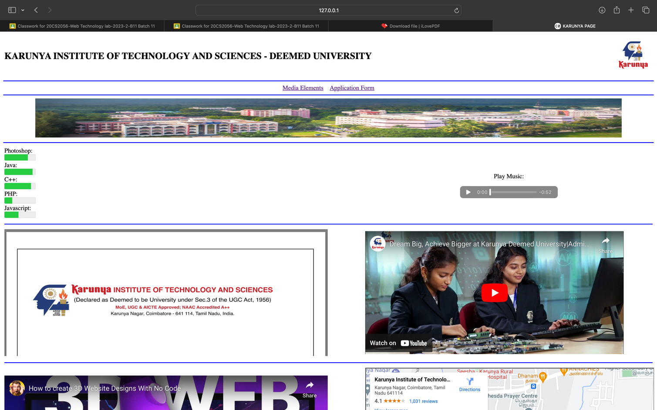

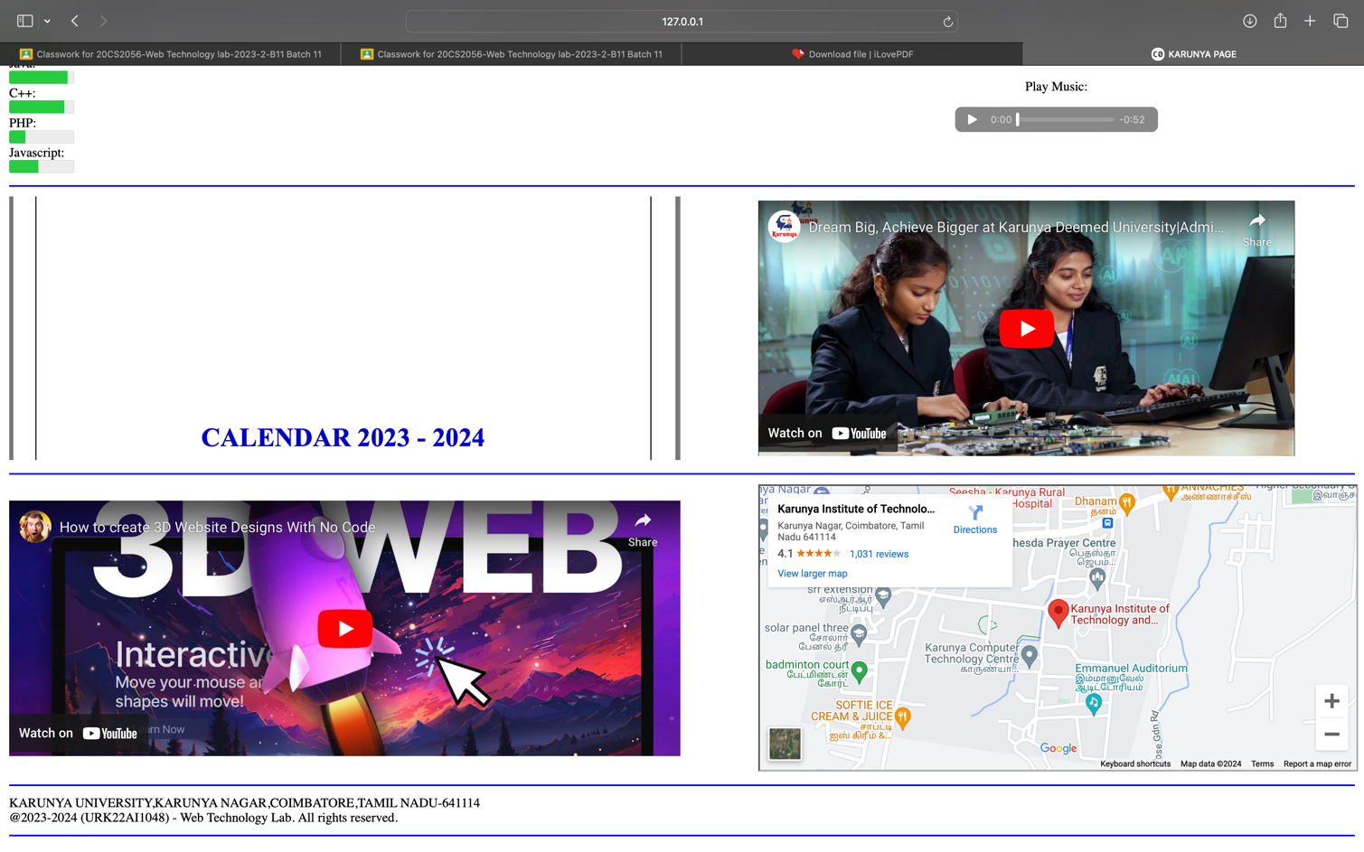

APPLICATION FORM:

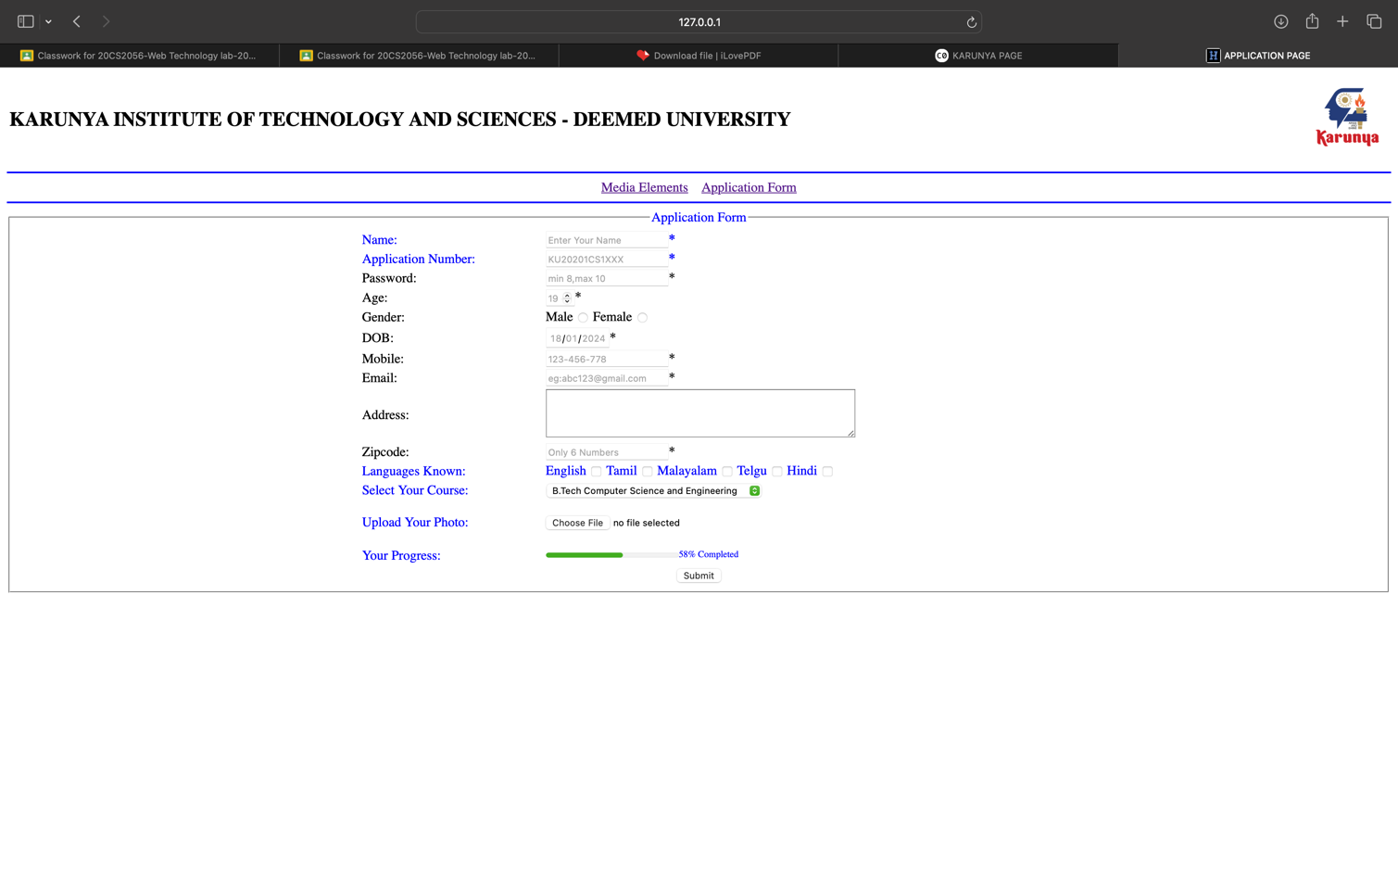

Result:

The above HTML5 index page and application form is displayed successfully executed and verified.